
Tertiary Infotech Academy Pte Ltd
UEN: 201200696W
LEARNER GUIDE
For
Mastering Articulate Storyline 360 for e-Learning Content Creation
TGS Ref No: TGS-2024042308
Conducted by
Tertiary Infotech Academy Pte Ltd
UEN: 201200696W
Version 9

DOCUMENT VERSION CONTROL RECORD
Version Number | Effective Date of Release | Summary of Included Changes | Author
8.0 | Legacy release | Previous 947-slide trainer deck and original Storyline exercise set. | Tertiary Infotech Academy
9 | 21 August 2026 | Rebuilt aligned guide covering 40 Storyline concepts and nine self-contained .story labs with detailed procedures, evidence and acceptance criteria. | Dr Alfred Ang

TABLE OF CONTENTS
Right-click and choose “Update Field”, or press F9, to build the table of contents.

Purpose and Use
This guide contains the detailed Storyline 360 procedures, evidence requirements and acceptance criteria intentionally omitted from the visual course slides. Every lab includes BEGIN and END .story files: work from a named copy of BEGIN, keep both originals unchanged, and retain your completed .story project plus evidence.

Learning Outcomes
- LO1: Conceptualise and map digital storyboards integrating principles of storytelling in Storyline 360.
- LO2: Identify and determine diverse e-learning content aligned with audience preferences, industry trends and content features.
- LO3: Determine effective modes and processes for distributing interactive e-learning content.
- LO4: Develop guidelines and determine content delivery frequency for effective e-learning delivery.

TSC Alignment
Code | Knowledge / Ability
K1 | Principles of digital storytelling
K2 | Potential customers' evolving preferences for content types, styles and modes of delivery
K3 | Process of developing a digital storyboard
K4 | Parameters for delivering content for marketing purposes
K5 | Features of marketing content
K6 | Modes of content delivery for marketing
A1 | Conceptualise content ideas to meet marketing objectives
A2 | Map out digital storyboards as part of a content strategy
A3 | Identify content requirements from customer and potential-customer preferences
A4 | Determine the frequency of delivering marketing content to customers
A5 | Determine the types and styles of content to deliver to customers
A6 | Determine modes and processes for distributing content
A7 | Develop guidelines for content-strategy execution

Core Professional Workflow
1. Clarify the business objective, learner audience, device, delivery channel and constraints.
2. Map screens, narration, media, interactions, branches, accessibility and evidence in the storyboard.
3. Work locally from a versioned copy of the supplied BEGIN .story file and preserve the END reference.
4. Use reusable themes, layouts, named objects, layers, states, triggers and variables deliberately.
5. Check rights, provenance, alternative text, focus order, captions and keyboard operation as content is added.
6. Preview the slide, scene and project; test correct, incorrect, boundary, revisit and resume paths.
7. Publish only to the approved review/test target, verify runtime/tracking and retain the source plus evidence.

Topic 1 — Get Started on Articulate Storyline 360
Story purpose · storyboard · project model · interface · scenes · slides · layers · quizzes · media libraries
Alignment: LO1 · A1 · A2 · K1 · K3

Digital Storytelling as a Learning System
A digital story combines a purposeful narrative, evidence, media and learner agency so attention leads to a decision or behaviour.
Best used for: Onboarding, compliance, product education and scenario-based learning where context matters.
Key controls: Audience; objective; protagonist; tension; choice; consequence; evidence; reflection.
Watch for: Decorative stories with no decision, irrelevant emotion or a message that conflicts with the learning objective.
Quality evidence: The narrative can be traced from business objective to learner action and measurable outcome.

Storyboard Architecture
A storyboard makes the course visible before production by mapping screens, narration, media, interactions, transitions, branching and evidence.
Best used for: Stakeholder alignment, estimating effort, accessibility planning and preventing expensive rework.
Key controls: Screen ID; purpose; on-screen copy; narration; asset; interaction; branch; accessibility; owner; status.
Watch for: Treating the storyboard as a static script or failing to show conditional paths and feedback.
Quality evidence: Every screen has a purpose, every branch reconnects or terminates deliberately, and every asset has an owner.

Audience, Objective and Content Promise
A content promise states what the learner will be able to decide or do and why the experience is worth completing.
Best used for: Selecting scope, tone, examples and interaction depth for a defined audience.
Key controls: Role; prior knowledge; device; context; time; motivation; risk; desired behaviour.
Watch for: Beginning with software features instead of learner need, or promising outcomes the content cannot support.
Quality evidence: The opening, activities and assessment all support the same learner promise.

Project Model and File Discipline
A .story file packages scenes, slides, layers, media, triggers, variables, player settings and project metadata.
Best used for: Versioned authoring, team handoff, recovery and evidence retention.
Key controls: Local working drive; short path; version name; backup; media links; publish folder; archive.
Watch for: Authoring directly on a network/removable drive, overwriting the only copy or confusing published output with the source.
Quality evidence: The source opens locally, the version is identifiable and a separate backup exists.

Story View, Slide View and Interface
Story View reveals course flow; Slide View reveals one screen's objects, layers, timeline, states, triggers and properties.
Best used for: Choosing the right view for architecture versus detailed construction.
Key controls: Ribbon; scenes; slide canvas; timeline; states; notes; layers; triggers; properties; zoom.
Watch for: Editing details without checking navigation or interpreting Story View connectors as decorative lines.
Quality evidence: A reviewer can identify scene boundaries, navigation paths and the objects controlling the selected slide.

Scenes, Slides and Navigation Order
Scenes group related slides while triggers determine actual navigation, including non-linear branches.
Best used for: Modules, alternate pathways, remediation and reusable course sections.
Key controls: Scene start; slide order; next/previous triggers; jump target; branching; revisit behaviour.
Watch for: Assuming visual order equals runtime order or creating branches with no return/exit path.
Quality evidence: Preview proves every intended route, back path and terminal state.

Slides, Layers and Revisit Behaviour
A base slide can reveal layers without leaving the slide; layer properties decide visibility, timeline and revisit behaviour.
Best used for: Progressive disclosure, modal explanations, feedback and controlled exploration.
Key controls: Hide other layers; hide base objects; prevent clicking; pause base; reset/resume/automatic revisit.
Watch for: Unexpected reset, hidden content exposed to assistive technology or click-through behind a modal layer.
Quality evidence: Layer open/close, focus, timeline and revisit behaviour match the storyboard.

Question Slides and Form/Slide Views
Form View defines question data and scoring; Slide View controls the visual and interactive presentation.
Best used for: Building graded and survey questions while preserving design control.
Key controls: Question type; prompt; choices; correct response; shuffle; attempts; required; score; feedback; branch.
Watch for: Designing before the scoring model is stable or using a question type that excludes keyboard users.
Quality evidence: Preview shows correct scoring, feedback and navigation for correct, incorrect and incomplete responses.

Result Slides and Completion Logic
A result slide aggregates selected questions or other result slides and can drive completion, pass/fail and retry logic.
Best used for: Quizzes, assessments, knowledge checks and LMS reporting.
Key controls: Tracked questions; passing score; timer; attempts; submit all; retry; review; completion trigger.
Watch for: A result slide that tracks the wrong questions or reports completion before required interaction.
Quality evidence: Test attempts prove pass, fail, retry and resume outcomes; reported score matches the visible result.

Question Banks, Media Library and Content Library
Question banks randomise reusable questions; Media Library centralises project assets; Content Library supplies reusable templates and media.
Best used for: Scaling consistent courses, controlled variation and efficient asset updates.
Key controls: Bank draw; random count; reuse; replace asset; accessibility metadata; template consistency.
Watch for: Random draws that miss required coverage or replacing media without checking crops, captions and rights.
Quality evidence: Each draw covers the intended criteria and asset replacement updates all expected instances.

Lab 01 — Replace Visuals and Establish a Theme
Scenario: Creative Minds is adapting a camping orientation template for a new learning campaign and needs a consistent visual identity without rebuilding the course.
Objective: Replace supplied media and harmonise the project theme while preserving scene structure and navigation.
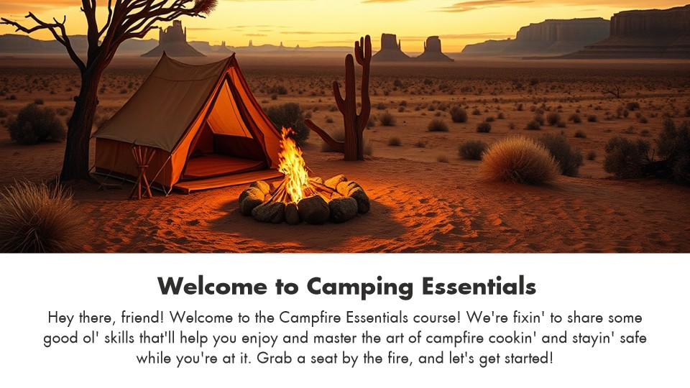
Supplied Storyline files: 03_01_BEGIN.story and 03_01_END.story

Detailed Procedure
1. Copy `03_01_BEGIN.story` to a new working file; keep the BEGIN and END files untouched as the baseline and reference.
2. Open the working copy from a local Windows drive and review all three slides in Story View and Slide View.
3. Record the current theme fonts, theme colours, slide size, layouts and player before making changes.
4. Use Replace Picture or the Media Library to substitute the relevant camping visuals without changing object geometry.
5. Apply a coherent font and colour theme that supports projection contrast and the course audience.
6. Check every replaced picture for crop, aspect ratio, focal point and alternative text.
7. Preview the full scene and confirm the Begin control and navigation still work.
8. Compare your result against `03_01_END.story`; note one deliberate difference and why it improves the brief.
9. Save as `Lab-01-YourName.story` in this lab folder.

Evidence to Retain
Retain the working .story file plus screenshots of Story View, one edited slide and the theme settings.

Acceptance Criteria
- Both original BEGIN and END .story files remain unchanged.
- All replaced media preserves aspect ratio and readable composition.
- Theme choices are consistent and meet contrast requirements.
- Navigation and preview behave as before.
Lab folder: labs/lab-01-replace-visuals-and-theme/

Lab 02 — Populate the Storyboard with Course Content
Scenario: The same camping course now needs meaningful module descriptions and supporting imagery before stakeholder review.
Objective: Turn a skeletal template into a storyboard-aligned three-slide course overview using reusable project assets.
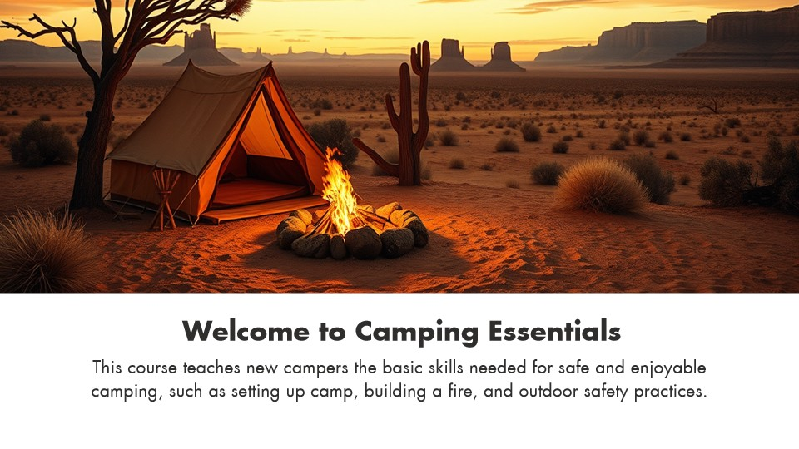
Supplied Storyline files: 03_02_BEGIN.story and 03_02_END.story

Detailed Procedure
1. Create `Lab-02-YourName.story` from `03_02_BEGIN.story` and open it locally.
2. Review the learning promise and define the purpose of each of the three slides.
3. Write concise learner-facing descriptions for campsite selection, campfire safety and essential toiletries.
4. Import or replace the supplied supporting pictures through the Media Library so assets remain traceable.
5. Use slide titles, hierarchy, alignment and spacing to make the intended reading order obvious.
6. Add meaningful alternative text; remove decorative objects from the focus order where appropriate.
7. Preview each slide at Fit and 100% zoom and test keyboard focus order.
8. Compare against `03_02_END.story` and record how the storyboard maps to the final slide content.
9. Save the completed working file and evidence screenshots.

Evidence to Retain
Retain the completed .story file, a three-screen storyboard table and accessibility/focus-order screenshots.

Acceptance Criteria
- Each slide has one clear purpose and concise copy.
- The three descriptions and visuals match the intended module topics.
- Focus order and alternative text support meaningful navigation.
- The project previews without missing media.
Lab folder: labs/lab-02-populate-storyboard-content/

Topic 2 — Working with Assets
Pictures · 360° media · video · audio · captions · accessibility · web content · screen recordings · text and layout
Alignment: LO2 · A3 · A5 · K2 · K5

Content Requirements from Audience Preferences
Content type, length, style, interaction and channel are selected from audience evidence rather than author preference.
Best used for: Microlearning, mobile use, multilingual audiences and role-specific performance support.
Key controls: Persona; device; bandwidth; accessibility; context; frequency; tone; data sensitivity.
Watch for: Equating novelty with relevance or using a single format for every audience.
Quality evidence: A requirements matrix links each preference to a design and delivery response.

Pictures and Visual Hierarchy
Pictures carry meaning when crop, contrast, focal point and proximity support the message.
Best used for: Context-setting, demonstrations, comparison and emotional framing.
Key controls: Crop; size; position; transparency; recolour; alt text; compression; replace picture.
Watch for: Low-resolution sources, decorative clutter, stretched images or text placed over busy detail.
Quality evidence: The focal point survives projection and mobile viewing, and the image has appropriate alternative text.

360° Images, Markers and Hotspots
A 360° image creates an explorable environment; markers present information and hotspots define interactive regions.
Best used for: Virtual tours, safety inspections, product familiarisation and spatial decisions.
Key controls: Initial view; marker; hotspot; label; media; navigation; accessibility; completion rule.
Watch for: Hidden required targets, motion discomfort, inaccessible hotspots or no cue that the scene is interactive.
Quality evidence: Keyboard and pointer tests reach every required target and the learner knows when exploration is complete.

Video as Demonstration Evidence
Video shows change over time but requires deliberate pacing, controls, compression and an accessible alternative.
Best used for: Procedural demonstrations, expert messages and behaviour modelling.
Key controls: Insert/website video; trim; poster frame; playback; controls; captions; transcript; quality.
Watch for: Autoplay with sound, unreadable screen detail, missing captions or interaction placed over video controls.
Quality evidence: Playback works in the publish target and captions/transcript convey equivalent information.

Audio, Narration and Closed Captions
Narration can guide attention while captions expose speech and meaningful sound to learners who cannot hear it.
Best used for: Story-led modules, demonstrations and multilingual or noisy environments.
Key controls: Record/import; waveform; trim; fade; volume; VTT captions; caption button; transcript.
Watch for: Narration duplicating every on-screen word, inconsistent levels, timing drift or captions covering controls.
Quality evidence: Audio is intelligible, synchronised and optional; captions are accurate and available in the player.

Accessibility: Focus, Names and Alternatives
The accessibility tree, focus order, object names and alternative text determine what keyboard and screen-reader users encounter.
Best used for: Every production course, especially custom navigation and layered interactions.
Key controls: Focus order; visible to accessibility tools; alt text; object name; tab sequence; focus indicator; language.
Watch for: Decorative objects announced, duplicate labels, illogical focus or interactions that depend only on hover/drag.
Quality evidence: Keyboard-only and screen-reader walkthroughs preserve meaning, order and operability.

Web Objects and External Content
A web object embeds or launches web content while the course remains responsible for context, security and fallback.
Best used for: Live reference tools, maps, simulations or approved external services.
Key controls: URL/local web folder; load automatically/on click; display in slide/new window; fallback link; focus.
Watch for: Third-party tracking, mixed content, offline failure, broken focus or assuming embedded content is accessible.
Quality evidence: Published tests confirm access, fallback, privacy expectations and keyboard exit from the object.

Screen Recording Modes
One recording can be inserted as a video or as step-by-step View, Try and Test slides.
Best used for: Software demonstrations, coached simulations and performance checks.
Key controls: Recording area; microphone; screen size; video/View/Try/Test; action captions; mouse path; edits.
Watch for: Recording personal data, tiny UI, changing software versions or generating unreliable automatic steps.
Quality evidence: The learner can see the target action and the simulation accepts the intended interaction.

Shapes, Captions, Text Boxes and Tables
Native objects create editable structure, hierarchy and interactive targets without baking information into an image.
Best used for: Callouts, process graphics, labels, layouts and accessible data presentation.
Key controls: Fill; line; radius; text style; margins; alignment; table headers; accessibility; states.
Watch for: Small targets, low contrast, inconsistent typography or using a table only to position content.
Quality evidence: Objects remain editable, readable and logically ordered at the delivery size.

Formatting, Sizing and Positioning
Consistent alignment, spacing, size and theme choices reduce cognitive load and make interaction predictable.
Best used for: Templates, reusable components and multi-author projects.
Key controls: Align; distribute; size; position; rotation; guides; theme fonts/colours; format painter.
Watch for: Pixel-level drift, stretched media, accidental off-slide objects or inconsistent states.
Quality evidence: Shared edges and spacing are consistent; no object clips at common player sizes.

Lab 03 — Curate and Replace Audience-Fit Media
Scenario: Stakeholder feedback says the first visual set does not fit new campers in a contemporary learning context.
Objective: Evaluate customer preferences, select a suitable visual style and replace project assets consistently.
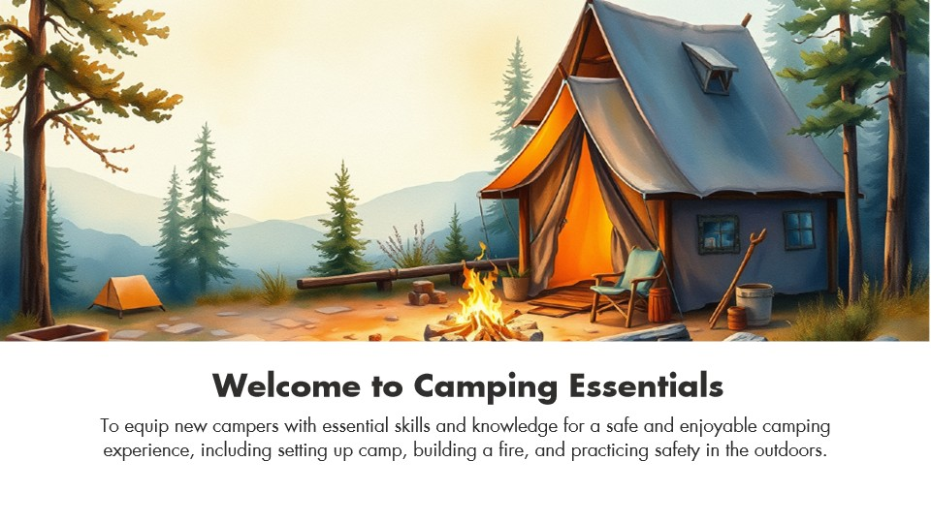
Supplied Storyline files: 04_01_BEGIN.story and 04_01_END.story

Detailed Procedure
1. Create `Lab-03-YourName.story` from `04_01_BEGIN.story`.
2. Define the audience, device, tone, cultural context and visual-selection criteria in the evidence sheet.
3. Open the Media Library and identify the assets used by each slide.
4. Select replacement visuals that match the criteria and have permitted usage rights.
5. Replace the assets through Storyline so all linked uses and crops can be checked.
6. Correct crop, position, contrast and hierarchy on each affected slide.
7. Update alternative text and remove purely decorative imagery from the accessibility tree.
8. Preview on desktop and responsive player views; inspect for missing media or unintended stretching.
9. Compare with `04_01_END.story`, save the completed .story file and record source/licence evidence.

Evidence to Retain
Retain the completed .story file, audience requirements matrix, asset/source register and before/after screenshots.

Acceptance Criteria
- Visual choices trace to audience requirements.
- No picture is stretched or visibly pixelated.
- Rights/provenance are documented.
- Alternative text and focus order are appropriate.
Lab folder: labs/lab-03-curate-and-replace-media/

Lab 04 — Create and Govern an AI-Assisted Visual Variation
Scenario: Creative Minds wants to test a western-poster visual direction without losing the approved baseline or provenance record.
Objective: Create an AI-assisted visual variation, evaluate it against the brief and retain transparent provenance evidence.
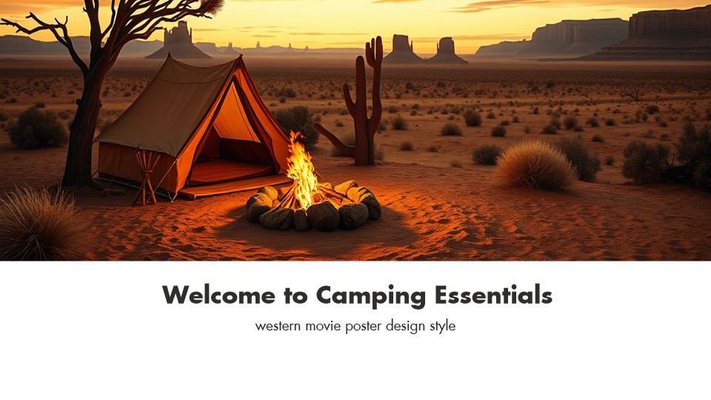
Supplied Storyline files: 04_02_BEGIN.story and 04_02_END.story

Detailed Procedure
1. Create `Lab-04-YourName.story` from `04_02_BEGIN.story` and preserve the supplied baseline.
2. Write an image brief covering subject, style, composition, audience, rights constraints and prohibited content.
3. Use the approved Storyline/Articulate image-generation feature or a trainer-approved image source.
4. Record the exact prompt, generation date, selected variation and any reference-image permissions.
5. Insert or replace the visual without stretching and adjust crop so the focal point supports the message.
6. Review hands, objects, cultural details, accidental text, bias, plausibility and brand suitability.
7. Add alternative text that communicates instructional meaning rather than the generation method.
8. Compare with `04_02_END.story`, explain whether the western-poster direction should be accepted, adapted or rejected.
9. Save the .story file and the provenance/evaluation evidence.

Evidence to Retain
Retain the completed .story file, prompt/provenance record, evaluation checklist and before/after screenshots.

Acceptance Criteria
- A baseline remains available for comparison.
- The visual is technically plausible and free of accidental text/logos.
- The decision is justified against audience and brand criteria.
- Provenance and rights evidence are complete.
Lab folder: labs/lab-04-ai-assisted-visual-variation/

Lab 05 — Add Narration and Closed Captions
Scenario: The course needs optional narration for guidance and accurate captions for learners in noisy or hearing-limited contexts.
Objective: Add and synchronise narration, captions and accessible playback controls without duplicating unnecessary on-screen text.

Supplied Storyline files: 05_01_BEGIN.story and 05_01_END.story

Detailed Procedure
1. Create `Lab-05-YourName.story` from `05_01_BEGIN.story`.
2. Review the narration script and mark pronunciation, pause and emphasis cues.
3. Import or record narration on the intended slide and inspect the waveform.
4. Trim silence, normalise perceived level and add short fades where needed.
5. Import or create the supplied VTT captions and correct timing and wording.
6. Confirm the player exposes captions and that keyboard users can operate the control.
7. Align object timing to narration using the playhead or cue points where appropriate.
8. Preview with audio on, audio muted and captions on; check that captions do not cover essential content.
9. Compare with `05_01_END.story` and save the completed .story file and evidence.

Evidence to Retain
Retain the completed .story file, caption-timing screenshot, waveform/timeline screenshot and accessibility test record.

Acceptance Criteria
- Narration is intelligible and synchronised.
- Captions accurately represent speech and meaningful sound.
- Captions are available through an operable control.
- On-screen text and narration avoid unnecessary duplication.
Lab folder: labs/lab-05-narration-and-captions/

Lab 06 — Build a Multi-Slide Audio and Caption System
Scenario: A three-slide course needs consistent narration, caption files and learner control across the whole scene.
Objective: Implement multiple audio/caption tracks consistently and validate timing, focus and playback behaviour across slides.

Supplied Storyline files: 05_02_BEGIN.story and 05_02_END.story

Detailed Procedure
1. Create `Lab-06-YourName.story` from `05_02_BEGIN.story`.
2. Inventory the supplied MP3 and VTT assets and map each pair to its target slide.
3. Import each narration track and apply a consistent naming convention in the timeline and Media Library.
4. Attach the matching caption file and correct text/timing errors.
5. Set playback and slide-advance behaviour so narration is neither cut off nor repeated unexpectedly.
6. Expose caption and volume controls consistently in the player.
7. Verify focus order, alternative text and accessible object visibility on every slide.
8. Preview the complete scene using normal navigation, replay and revisit; log any resume differences.
9. Compare with `05_02_END.story`, save the completed .story file and test matrix.

Evidence to Retain
Retain the completed .story file, media map, scene-wide audio/caption test matrix and representative screenshots.

Acceptance Criteria
- All audio and captions map to the correct slides.
- Naming and control behaviour are consistent.
- Revisit/replay does not create overlapping or missing narration.
- Keyboard and caption checks pass on every slide.
Lab folder: labs/lab-06-multi-slide-audio-accessibility/

Topic 3 — Interactivity
Zoom regions · interactive objects · triggers · states · variables · timeline · branching · feedback · motion
Alignment: LO3 · A6 · K6

Zoom Regions and Guided Attention
A zoom region enlarges a defined area during the slide timeline to direct attention.
Best used for: Screen detail, maps and still-image close-ups where context can be restored.
Key controls: Region bounds; position; timeline start/end; speed; layer limitation; return to normal.
Watch for: Motion without purpose, unreadable destination detail or excessive zoom causing disorientation.
Quality evidence: The zoom begins when the explanation needs it and returns without hiding required context.

Buttons, Markers, Hotspots and Controls
Interactive objects expose actions through clear affordances, states, labels and trigger responses.
Best used for: Exploration, reveal interactions, custom navigation and decision points.
Key controls: Target size; normal/hover/selected/visited/disabled; alt text; trigger; focus order; feedback.
Watch for: Invisible hotspots, tiny targets, colour-only state changes or controls that look decorative.
Quality evidence: Pointer, keyboard and screen-reader users can identify, operate and understand every control.

Trigger Anatomy and Execution Order
A trigger performs an action on an object or variable when an event occurs, optionally under conditions.
Best used for: Navigation, layer control, state changes, media control, scoring and custom logic.
Key controls: Action; target; event; object; condition; order; scope; copied trigger.
Watch for: Correct triggers in the wrong order, triggers attached to covered objects or ambiguous next-slide targets.
Quality evidence: Trigger panel order matches the logic diagram and tests prove every condition path.

Object States
States store visual versions of one object; built-in states may respond automatically while custom states need explicit logic.
Best used for: Selection, progress, disabled controls, visited indicators and feedback.
Key controls: Normal; hover; down; selected; visited; disabled; custom; initial state; edit states.
Watch for: Duplicating objects instead of states, hiding critical meaning only in colour or leaving a disabled control focusable.
Quality evidence: State changes are predictable, perceivable and preserved appropriately on revisit.

Variables and Conditional Logic
Text, number and true/false variables retain information that triggers can evaluate to personalise or control flow.
Best used for: Progress gates, scores, names, branching, toggles and completion checks.
Key controls: Variable type; default; adjust; reference; condition; operator; scope; reset.
Watch for: Type mismatch, stale values on retry, multiple variables representing one fact or conditions evaluated too early.
Quality evidence: A test matrix proves default, boundary and reset cases and shows the variable value where needed.

Timeline, Cue Points and Synchronisation
The timeline controls when objects and media appear; cue points provide named anchors for synchronised actions.
Best used for: Narrated animation, timed reveals and media-coordinated interactions.
Key controls: Start/end; show until end; align to playhead; cue point; lock; visibility; waveform.
Watch for: Objects ending too early, animation drift after audio edits or a locked timeline hiding the cause.
Quality evidence: Playback remains synchronised after seeking, replay and common device performance variation.

Animations, Motion Paths and Transitions
Animations affect objects, motion paths move them, and transitions affect the change between slides.
Best used for: Demonstrating sequence, change, direction and continuity.
Key controls: Entrance/exit/emphasis; duration; delay; direction; path; orient to path; transition.
Watch for: Decorative motion, competing animations, motion-trigger mismatch or inaccessible information shown too briefly.
Quality evidence: Motion clarifies one teaching point and the static slide still communicates the complete meaning.

Freeform Interactions and Question Conversion
Existing objects can become selectable, drag-and-drop, text-entry or hotspot responses with scoring and feedback.
Best used for: Authentic decisions where standard question layouts are too restrictive.
Key controls: Convert to freeform; response objects; drop targets; correct set; attempts; feedback; accessibility.
Watch for: Beautiful interaction with ambiguous instructions, overlapping targets or keyboard-inaccessible drag behaviour.
Quality evidence: The interaction has an accessible equivalent and correct/incorrect outcomes match the rubric.

Branching Scenarios and Consequences
Branches let learner choices reveal consequences, coaching and alternative routes before reconnecting to a common outcome.
Best used for: Conversations, safety decisions, customer handling and ethical choices.
Key controls: Decision node; choice; consequence; feedback; variable; branch map; merge point; retry.
Watch for: Branches that differ only cosmetically, dead ends, exponential complexity or moralising feedback.
Quality evidence: Every route has a defined purpose, duration and outcome; the storyboard accounts for all nodes.

Interaction QA and Evidence
Interaction quality is demonstrated with a test matrix covering behaviour, accessibility, content and device conditions.
Best used for: Before stakeholder review, LMS upload and formal assessment.
Key controls: Happy path; wrong path; boundary; revisit; retry; keyboard; captions; focus; responsive player; resume.
Watch for: Testing only the author’s preferred path or relying on preview when the publish target behaves differently.
Quality evidence: A signed checklist records expected versus actual results and links defects to corrected versions.

Lab 07 — Build a Graded Question with Feedback
Scenario: The camping module needs a defensible knowledge check on campsite-selection criteria.
Objective: Add a graded question with plausible distractors, feedback, scoring and accessible response behaviour.

Supplied Storyline files: 06_01_BEGIN.story and 06_01_END.story

Detailed Procedure
1. Create `Lab-07-YourName.story` from `06_01_BEGIN.story`.
2. Define the learning objective and write one decision-focused question with one defensible correct answer.
3. Insert the appropriate graded question type and configure prompt, choices and correct response.
4. Write concise feedback that explains why each response is correct or incorrect.
5. Set attempts, score, required status and navigation to match the storyboard.
6. Format response states with more than colour alone and verify focus/reading order.
7. Preview correct, incorrect, incomplete, retry and revisit paths.
8. Compare with `06_01_END.story`; verify that the result/completion model receives the intended score.
9. Save the completed .story file and test evidence.

Evidence to Retain
Retain the completed .story file, question specification, trigger/feedback screenshots and a five-case test matrix.

Acceptance Criteria
- Question and feedback align to the taught criterion.
- Scoring and attempts behave as specified.
- All response states are perceivable and keyboard operable.
- Correct, incorrect, incomplete, retry and revisit tests pass.
Lab folder: labs/lab-07-graded-question-and-feedback/

Lab 08 — Build a Multi-Question Quiz and Result Logic
Scenario: The course team must expand the check to cover campsite selection and essential equipment while reporting a reliable result.
Objective: Create a multi-question quiz with single- and multiple-response items, feedback, result logic and retry behaviour.

Supplied Storyline files: 06_02_BEGIN.story and 06_02_END.story

Detailed Procedure
1. Create `Lab-08-YourName.story` from `06_02_BEGIN.story`.
2. Map each question to its learning criterion and define the acceptable evidence.
3. Add a single-response question about safe campsite selection and a multiple-response question about essential equipment.
4. Configure correct options, scores, attempts, required status and feedback for every choice.
5. Add or update the result slide; select the intended tracked questions and passing score.
6. Configure submit, retry and review behaviour without exposing correct answers prematurely.
7. Check focus order, response states and clear instructions for the multiple-response interaction.
8. Preview pass, fail, retry, partial selection, resume and review paths.
9. Compare with `06_02_END.story`, save the completed .story file and results test log.

Evidence to Retain
Retain the completed .story file, question-to-criterion map, result settings screenshot and pass/fail/retry test log.

Acceptance Criteria
- Both questions assess the mapped criteria.
- The result slide tracks the correct items and score.
- Retry and review behave as intended.
- Keyboard, focus and instruction checks pass.
Lab folder: labs/lab-08-multi-question-quiz-results/

Topic 4 — Presentation, Review and Distribution
Themes · masters · player · accessibility · Review 360 · preview · LMS/LRS publishing · scheduling · governance
Alignment: LO4 · A4 · A7 · K4

Themes, Slide Masters and Design Governance
Themes define fonts and colours while masters/layouts define reusable structure and inheritance.
Best used for: Brand consistency, accessible templates and efficient multi-course production.
Key controls: Theme fonts; theme colours; master; layout; placeholder; background; inherited object.
Watch for: Direct formatting everywhere, editing the wrong level or using master objects as essential interaction targets.
Quality evidence: New slides inherit approved typography, contrast and geometry without manual repair.

Player Features and Navigation
The player wraps course content with menu, controls, resources, seekbar, captions and responsive behaviour.
Best used for: Consistent navigation, learner control and delivery context.
Key controls: Modern/classic player; menu; previous/next; seekbar; volume; captions; resources; labels; resume.
Watch for: Player controls conflicting with custom navigation, unrestricted seeking bypassing required content or hidden captions.
Quality evidence: The player supports the storyboard, accessibility plan and completion rules on desktop and mobile.

Accessible Player and Focus Styling
Player accessibility settings affect readable text, focus visibility, keyboard navigation and learner control.
Best used for: Courses intended for broad public or workforce access.
Key controls: Accessible text; focus colour; zoom-to-fit; keyboard shortcuts; labels; captions; playback speed.
Watch for: Low-contrast focus, disabling navigation shortcuts without an equivalent or assuming authoring preview proves accessibility.
Quality evidence: Published output passes keyboard, zoom, focus and assistive-technology checks.

Review 360 Collaboration
Review 360 publishes a review copy where stakeholders comment against slides and versions.
Best used for: Structured review, distributed stakeholders and traceable approval.
Key controls: Publish/update item; reviewer link; password; comments; replies; resolve/reopen; version.
Watch for: Using comments as the only requirement record, sharing sensitive content broadly or overwriting an approved version.
Quality evidence: Comments have owners and dispositions; the approved version maps to the retained .story source.

Preview Strategy and Publish-Only Tests
Preview tests authoring logic quickly, while published output is required for web objects, LMS communication and final runtime behaviour.
Best used for: Progressive QA from slide to scene to full course and target environment.
Key controls: Preview slide/scene/project; replay; device view; publish; browser test; console/LMS test.
Watch for: Treating preview as final evidence or testing only one browser and screen size.
Quality evidence: The final package is tested in its actual browser/LMS target using the acceptance matrix.

Publishing Channels and Trade-offs
Storyline can publish to Review 360, web, video, Word, LMS/LRS and supported distribution platforms; each preserves different capabilities.
Best used for: Selecting delivery by interactivity, tracking, review, accessibility, connectivity and governance needs.
Key controls: Channel; interactivity; tracking; package; hosting; privacy; update process; offline need.
Watch for: Publishing interactive content as video, hosting LMS output as plain web content or exposing source files.
Quality evidence: The chosen channel supports the required interaction, tracking and audience access.

LMS/LRS Standards and Tracking
SCORM, AICC, xAPI and cmi5 package content and communicate different completion, score and activity data to a delivery system.
Best used for: Tracked learning, compliance evidence and analytics across compatible LMS/LRS platforms.
Key controls: Standard/version; completion trigger; result slide; passing score; reporting status; identifier; launch.
Watch for: Choosing a standard the LMS does not support, changing identifiers carelessly or testing only the launch page.
Quality evidence: A sandbox launch records the intended status, score, completion and resume data.

Distribution Plan and Delivery Frequency
A distribution plan maps audience segments to channels, release timing, reminders, maintenance and measurement.
Best used for: Campaign learning, product launches, onboarding waves and recurring compliance content.
Key controls: Audience; channel; cadence; time zone; dependency; owner; metric; refresh trigger; escalation.
Watch for: Sending too frequently, ignoring local time/context or publishing updates without change communication.
Quality evidence: The plan justifies frequency and records owner, success measure and update rule.

Content Strategy Execution Guidelines
Guidelines turn repeated design and publishing decisions into a governed, reviewable operating model.
Best used for: Multi-author teams and courses that need consistent quality over time.
Key controls: Voice; brand; accessibility; interaction patterns; naming; review gates; rights; publishing; archive.
Watch for: A style guide that covers appearance but not behaviour, evidence, ownership or exceptions.
Quality evidence: A new author can build and publish a compliant module using the guideline and checklist.

Maintenance, Analytics and Lifecycle
Published learning is monitored, reviewed and retired using learner evidence, defects, content age and business change.
Best used for: High-use, regulated or frequently changing learning portfolios.
Key controls: Owner; version; review date; analytics; feedback; defect priority; source change; retirement; archive.
Watch for: No owner, links that outlive the source, silent changes or metrics collected without a decision purpose.
Quality evidence: The lifecycle register identifies current version, review trigger, decision and preserved evidence.

Lab 09 — Add a Summary, Review and Publish Plan
Scenario: Creative Minds is preparing the camping course for stakeholder review and a controlled LMS release.
Objective: Create a useful summary slide, define review criteria and configure a publish plan aligned with channel, tracking and delivery frequency.

Supplied Storyline files: 07_02_BEGIN.story and 07_02_END.story

Detailed Procedure
1. Create `Lab-09-YourName.story` from `07_02_BEGIN.story`.
2. Add a summary slide that states the key campsite setup actions and a clear next step.
3. Apply the project theme and accessible heading, reading order and alternative-text conventions.
4. Check navigation into and out of the summary, including revisit behaviour.
5. Preview the full scene and complete the interaction/accessibility test matrix.
6. Prepare a Review 360 plan naming reviewers, review questions, owner, deadline and comment disposition.
7. Select a distribution target and justify web, video, Review 360 or LMS/LRS against interaction and tracking needs.
8. For LMS/LRS, specify the supported standard, completion trigger, passing rule and sandbox test; do not upload to a live LMS in this lab.
9. Define delivery frequency, reminders, content owner, review date and update trigger.
10. Compare with `07_02_END.story`, save the completed .story file and publish plan.

Evidence to Retain
Retain the completed .story file, summary screenshot, QA matrix, Review 360 plan and distribution/frequency decision record.

Acceptance Criteria
- The summary communicates the intended actions and next step.
- Navigation and accessibility tests pass.
- The chosen channel supports required interaction and tracking.
- The delivery and maintenance plan identifies cadence, owner and update trigger.
Lab folder: labs/lab-09-summary-review-and-publish/

Intellectual Property, Privacy and Responsible AI
Use only assets and personal information you created or are permitted to use. Record the source, owner, licence or consent, date, allowed modifications, commercial or redistribution scope and attribution requirement. Public visibility does not itself grant reuse permission. Review current Articulate and AI-service terms before commercial work, do not provide third-party content or personal data without authority, and retain prompt and provenance evidence where appropriate. This guide is educational information, not legal advice.

Publishing and Lifecycle Checklist
- The .story source and published output carry the intended version and owner.
- Preview and published-output tests cover navigation, scoring, resume, captions, focus and keyboard operation.
- The selected channel supports the required interaction and tracking.
- Delivery frequency, reminders, review date and update triggers are documented.
- Review comments are resolved or dispositioned before release.
- Source, media permissions, test evidence and the final package are retained together.

Source Register
Authority | Location
Official course page | https://www.tertiarycourses.com.sg/wsq-mastering-articulate-storyline-360-for-e-learning-content-creation.html
Legacy trainer deck v8 | reference/WSQ - Master Trainer Slides - Mastering Articulate Storyline 360 for e-Learning Content Creation - v8.pptx
Original Storyline lab packages | reference/articulate stories/03_01_BEGIN.story through 07_02_END.story
Drive assessment papers v2 | reference/tms/WA (SAQ) and PP Assessment plus answer keys
Approved assessment plan v5.0 | reference/tms/Assessment Plan_TGS-2024042308_v5.0.docx
Approved courseware mapping v1 | reference/tms/Courseware Mapping_TGS-2024042308_v1.docx
Articulate Storyline 360 User Guide | https://community.articulate.com/kb/user-guide-series/storyline-360-user-guide/1193854
Articulate Storyline 360 Accessibility Maturity Plan | https://www.articulate.com/about/accessibility/storyline-360-accessibility-maturity-plan/
Articulate publishing guidance | https://community.articulate.com/blog/articles/choosing-the-right-publishing-option-for-your-storyline-360-project/1131199

